3.4 I can explain the effectiveness of tests and reflect on their purpose

During our week’s project we did manual testing, also known as White Box Testing, to check our code works and whether each web page did as it was intended to do, e.g show pictures, the links go to the correct page etc.

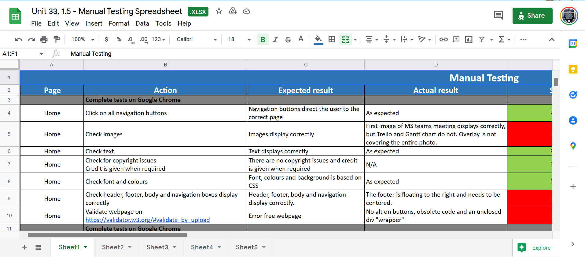

[The above shows an image of the manual testing spreadsheet we compiled all the data into]

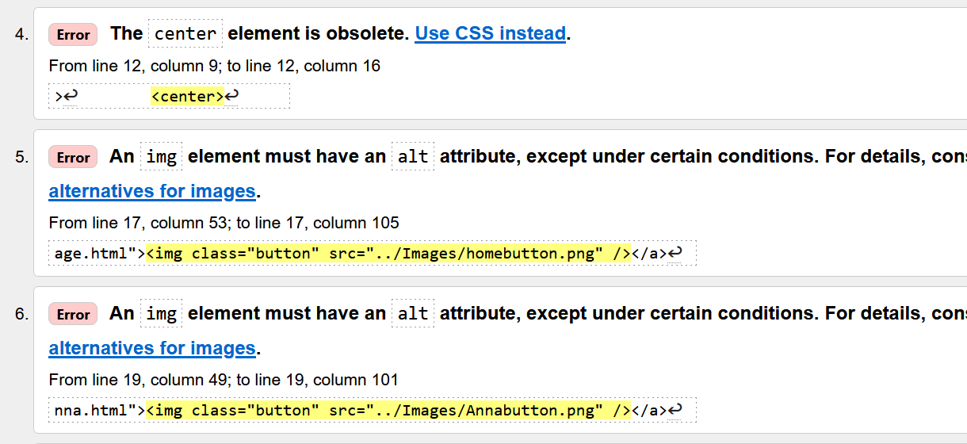

[The above shows an image of the validator testing I did on my web page that I created]

The benefit of this testing is that I can let people know in my team what errors I found and whether they need fixing or whether they are obsolete code that can still be used, like the <center> tag and left in the code.

If we did choose to do black box testing instead we would have had to have coded in an automated system that checked it for us but we would need more knowledge to do that.